Katerina Betts and Donald Hutchinson

Professor Charles Zimmer

Data Structures

20 February 2018

Lab 5: Templates and Exceptions

In Task 1, a class modelling a stable was created. An add and remove function were necessary to

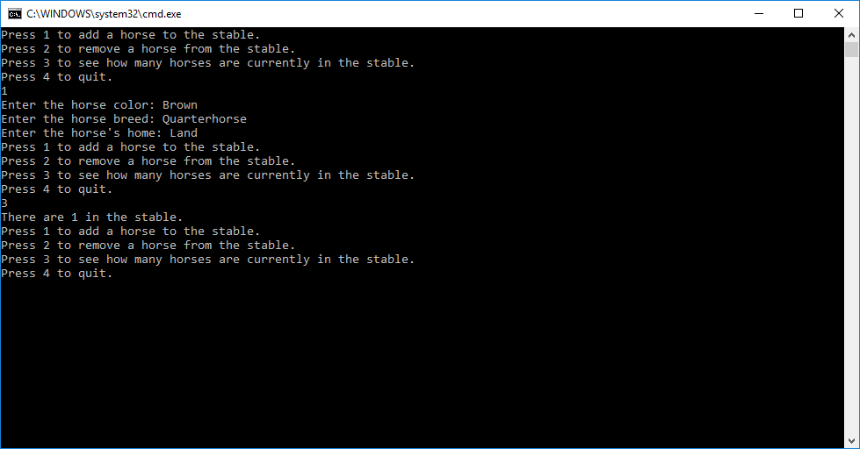

Add Horse

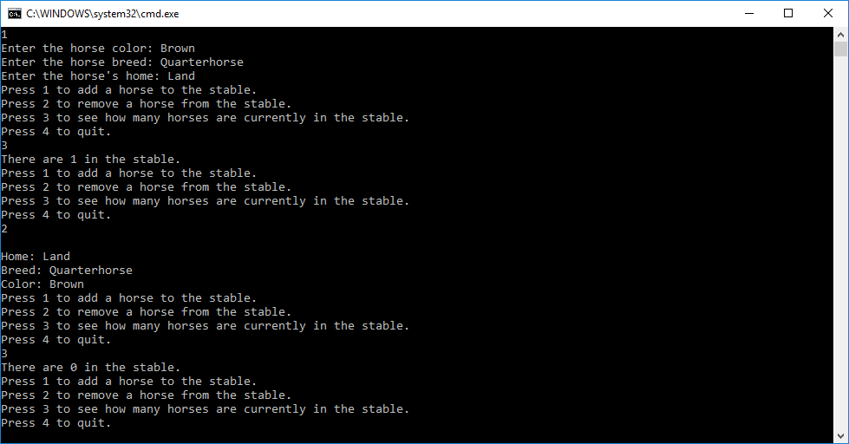

Remove horse

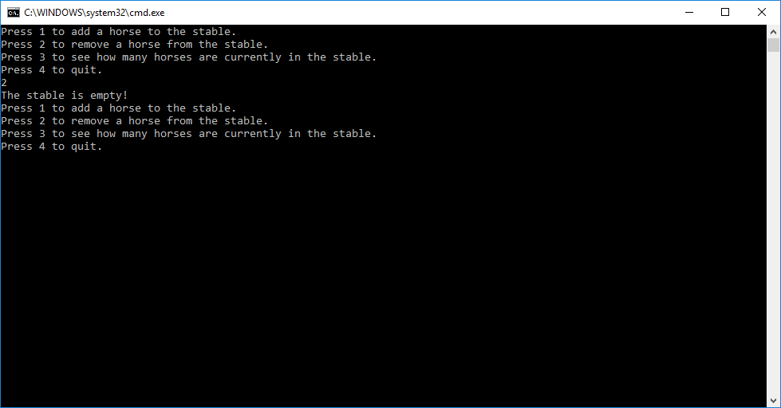

Empty Stable Exception

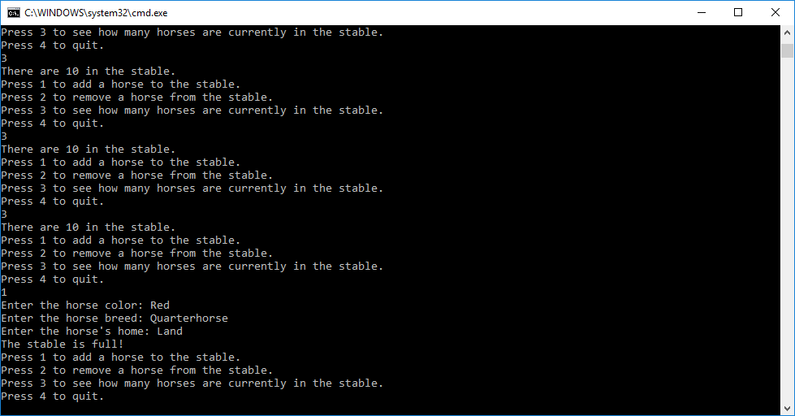

Full Stable Exception

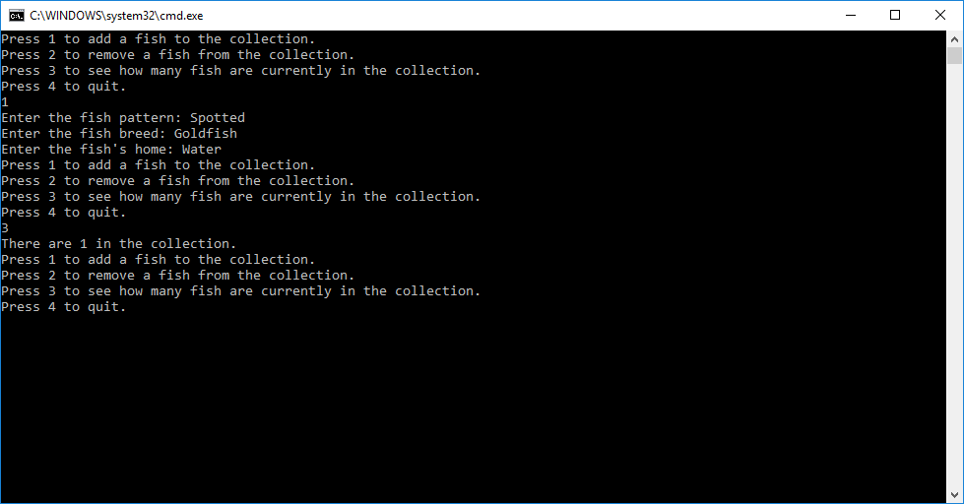

Add Fish

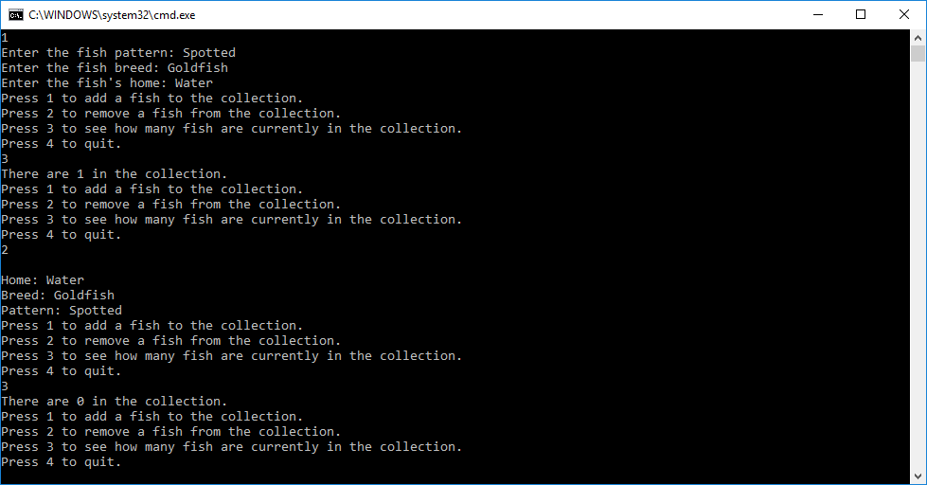

Remove Fish